**Verification of the BMTK implementation of the Hippocampus model**

**Cell Positions:**

The original model that this network is based off had a strictly defined geometry. This includes three distinct layers, each containing a uniform distribution of cells. The first layer contains 30 EC cells which are laid out in a 3x10 mm plate. The next plate represents the DG regions, its dimensions are 7.5x15mm. It contains 384 Granule Cells, 32 Basket Cells, and 32 Hipp cells. The Basket and Hipp cells use the same cell template as the Ca3 Basket and Ca3 OLM Cells respectively. The last plate represents the Ca3 region, its dimensions are 3x10mm. It contains 63 Pyramidal Cells, 8 Basket Cells, and 8 OLM Cells.

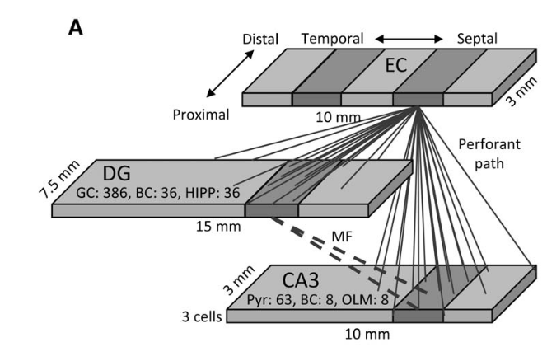

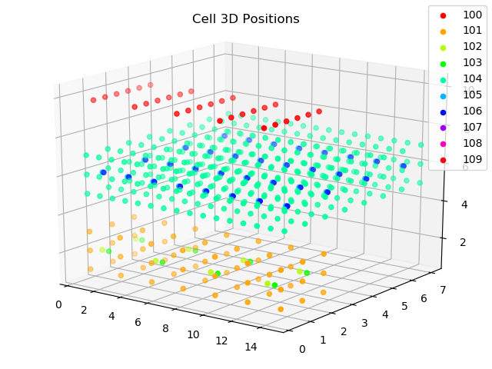

**The figure on the right shows the reported cell positions and their location in space whereas the figure on the left shows the geometry as it was laid out in the paper this model is based off.**

**Cell Connection Probability Distribution:**

The rules which determine if a cell connects to another cell in the network differ depending on data obtained from real world experiments. In general, the probability that a cell will connect to another cell in a different group is a gaussian distribution based on its distance from that cell in the XY plane (The Z distance is constant for each plate). The peak connection probability and standard deviation for each curve differs for each cell type.

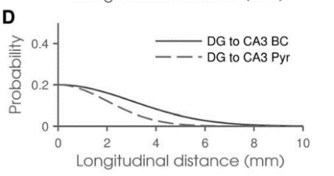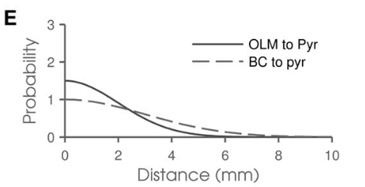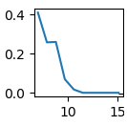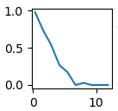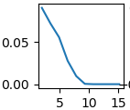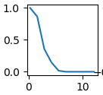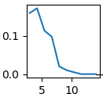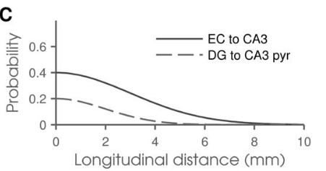**The above figures show specific connection probability distributions taken directly from the BMTK hippocampus model. The probabilities are very close to the reported target distributions shown below. The jaggedness of some of the plots can be attributed to a low cell count in such regions, thus the experimental probability is not as exact as the theoretical target probability. Furthermore, the peak probability for DG to Ca3 Pyramidal cells was not calculated the same way that the target plots were generated. Thus, the peak probability differs.**

EC to Ca3 Pyramidal

DG to Ca3 Pyramidal

BC to Ca3 Pyramidal

DG to Ca3 BC

OLM to Ca3 Pyramidal

**Cell FI Curve Analysis:**

The original Hippocampus paper did not report FI curves for this project. Therefore, we generated biologically acceptable ranges from reputable neuroscience papers and made sure that each cell’s FI curve fit within these ranges.

**Raster Plots:**

The network spiking changes throughout the duration of the experiment. The raster plot reports this information over time as a dot colored to correspond with a specific cell type and plotted against a cell ID number. This experiment consists of 16 trails where each trail contains 3 sets of 10 cell excitation events. There are 80ms gaps between each cell excitation event and 385ms gaps from the last cell excitation in a previous trail to the first event in a second trial. The first 6 trails provide inputs to cells numbered 0 to 9 inclusive while the last 10 trails provide inputs to cells numbered 10 to 19 inclusive.

**

**The figure on the left is the target raster plot. The figure on the left is the generated raster plot from the new BMTK model. It seems that the figure on the left is slightly less dense than the target plot. This could account for some of the jaggedness we see later in the pattern separation/completion plots.**

**Pattern Separation completion:**

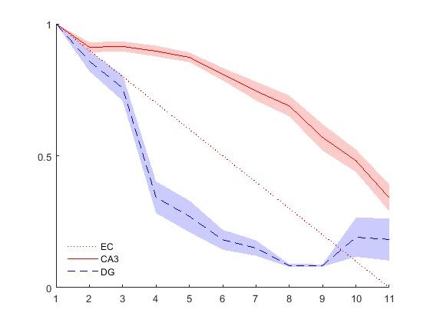The pattern separation completion plots summarize the results obtained from the raster plots. They measure the correlation between the cells active in the Ca3 region of the hippocampus along with the DG region. The input initial is a random configuration of EC cells. This pattern is varied by one cell per trail over 10 trials, resulting in a final pattern which is completely different from the initial pattern. Correlation is calculated by taking the dot product two vectors constructed from the cells active in the Ca3 and DG regions from the previous trial compared to and the current trial.

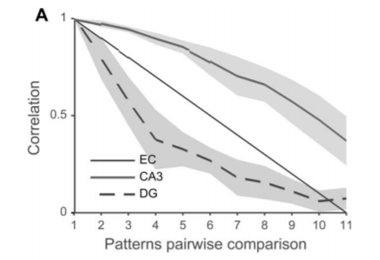

**The target plot is clearly smoother compared to the results obtained from this model. The exact reason for this is still unknown but most likely relates to the sparseness of the generated raster plot shown above. A sparser raster plot is known to produce less smooth correlation plots because less cells are active and the difference in vectors is likely to more drastic.**

**Binned Local Field Potentials:**